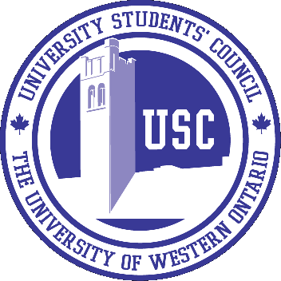

**Job Posting**

**Part-Time Cooks and Barista Positions**

**Position Summary**

The Spoke Restaurant located on the first floor of the UCC Building, Western University, are looking for part-time cooks and baristas to join our dynamic team for our restaurant which is being newly renovated and modernized for September 2017. We are very excited about the new look of our restaurant, kitchen, and café. Open seven days a week, 7:30am-1:00am, The Spoke is an ideal part-time position for students.

**General Responsibilities**

* Under the direction of the Kitchen Manager, part-time cooks will be required to complete orders in a timely manner
* Adhere to Health & Safety policies, training and regulations
* Food preparation
* Station set-up and clean-up
* Team-based production line

**Qualifications**

* Passion for food and new learning opportunities
* Highly motivated to work in a fast paced and ever-changing environment
* Works well under pressure
* Available to work weekends and late nights

**Compensation**

* We offer competitive pay for part-time employees

*Tentative Start Date*: Part-time cooks will commence in September 2017. Schedules will be coordinated with class schedules if applicable.

**Please forward Cover Letter and Resume by August 15th, 2017 at 5:00 PM to:**

**Adam Mortezof, Kitchen Manager**

**The University Students’ Council**

**Room 340, UCC Building**

**London, ON N6A 3K7**

**FAX: (519) 661-2094**

**amortezo@uwo.ca**

***Only those deemed qualified will receive notification of an interview. The University Students’ Council of the University of Western Ontario is an equal opportunity employer. The USC is committed to providing accommodations to those with disabilities. If you require an accommodation, we will work with you to meet your needs.***